Lab 4: Friend function, This pointer, DMA, Namespace

Objectives
- To understand how to define and use classes and objects in C++.
- To explore various types of constructors and destructors.
- To implement object referencing, friend functions, and this pointer.
- To use dynamic memory allocation and also namespace.

Tools and Libraries Used
• Programming Language: C++
• IDE: Code::Blocks
• Libraries: #include <iostream>, #include <cmath>, #include <string>

Theory
Static Members
Static members are shared among all objects. They are declared inside the class and defined outside using the :: scope resolution operator.
Syntax:
class ClassName {
static DataType VariableName;
static ReturnType FunctionName();
};
DataType ClassName::VariableName = InitialValue;
Example:
class Counter {
static int count;
public:
Counter() { count++; }
static void display() { cout << count; }
};
int Counter::count = 0;
Friend Function
A friend function is not a class member but can access its private and protected members.
Syntax:
class ClassName {
friend ReturnType FunctionName(ClassName &Object);
};
Example:
class Student {
string name;
int roll;
friend void update(Student &s);
};
void update(Student &s) {
s.name = "NewName";
s.roll = 10;
}
This Pointer
this is an implicit pointer to the current object, used inside non-static member functions.
Syntax:
ReturnType FunctionName() {
this->VariableName;
}
Example:
class Point {
int x, y;
public:
Point midpoint(Point p) {
int mx = (this->x + p.x) / 2;
int my = (this->y + p.y) / 2;
return Point(mx, my);
}
};
Namespace
Namespaces organize code and prevent name conflicts.
Syntax:
namespace NamespaceName {
class ClassName { };
}
Example:
namespace School {
class Student {
string name;
public:
void input() { cin >> name; }
void display() { cout << name; }
};
}
School::Student s;
s.input();
s.display();
Const Cast
const_cast removes the const qualifier to allow modification of constant data.
Syntax:
const TypeName* ptr;
TypeName* modPtr = const_cast<TypeName*>(ptr);
Example:
class Student {
string name;
int roll;
public:
void modify() const {
Student* s = const_cast<Student*>(this);
s->name = "Updated";
s->roll = 101;
}
};
const Student s;
s.modify();

1. Write a program to define a class that uses static data members and static member functions to count and display the number of objects created.
#include <iostream>
using namespace std;
class Counter {
private:
static int count; // Static data member to track object count
public:
// Constructor
Counter() {
count++;
cout << "Constructor called. Object number: " << count << endl;
}
static void displayCount() {
cout << "Total number of objects created: " << count << endl;
}
};
int Counter::count = 0;
int main() {
cout << "--- Object Creation ---" << endl;
Counter obj1;
Counter obj2;
Counter obj3;
cout << "--- Display Count Using Static Function ---" << endl;
Counter::displayCount(); // Call static function without object
return 0;
}
OUTPUT
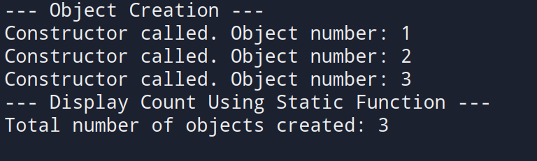

2. Write a program to create a class that uses a copy constructor to copy data from one object to another.
#include <iostream>
using namespace std;
class Student {
private:
int roll;
string name;
public:
// Parameterized constructor
Student(int r, string n) {
roll = r;
name = n;
cout << "Parameterized constructor called." << endl;
}
// Copy constructor
Student(const Student &s) {
roll = s.roll;
name = s.name;
cout << "Copy constructor called." << endl;
}
void display() {
cout << "Name: " << name << ", Roll Number: " << roll << endl;
}
};
int main() {
int r;
string n;
cout << "Enter student name: ";
getline(cin, n);
cout << "Enter roll number: ";
cin >> r;
cout << "\n--- Creating Original Object ---" << endl;
Student s1(r, n);
cout << "\n--- Creating Copy Using Copy Constructor ---" << endl;
Student s2 = s1;
cout << "\n--- Displaying Objects ---" << endl;
cout << "Original Object: ";
s1.display();
cout << "Copied Object: ";
s2.display();
return 0;
}
OUTPUT
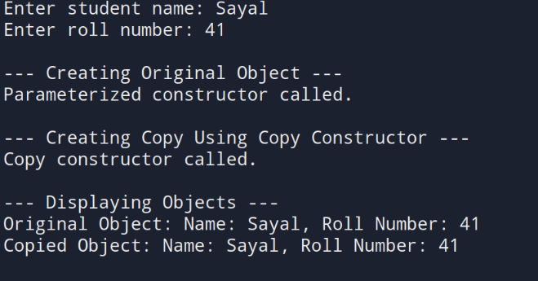
3. Write a program to dynamically allocate and deallocate memory for a single object and an array of objects using the new and delete operators.
#include <iostream>
#include <string>
using namespace std;

class Student {
private:
string name;
int roll;

public:
// Default constructor
Student() {
name = "";
roll = 0;
cout << "Student object created using default constructor." << endl;
}

// Parameterized constructor
Student(string n, int r) {
name = n;
roll = r;
cout << "Student object created using parameterized constructor." << endl;
}

void input() {
// To handle newline after integer input in main
// Note: Call cin.ignore() once before the first getline in main
cout << "Enter name: ";
getline(cin, name);
cout << "Enter roll number: ";
cin >> roll;
cin.ignore(); // ignore newline after reading roll number
}

void display() {
cout << "Name: " << name << ", Roll Number: " << roll << endl;
}

// Destructor
~Student() {
cout << "Destructor called for student: " << name << endl;
}
};

int main() {
// Dynamic allocation for single object
cout << "--- Dynamic Allocation for Single Object ---" << endl;
Student* s1 = new Student;

// For first input, no leftover newline, so no ignore here
s1->input();
s1->display();

delete s1; // deallocate memory

// Dynamic allocation for array of objects
int n;
cout << "\nEnter number of students: ";
cin >> n;
cin.ignore(); // ignore leftover newline before getline in input()

Student* sArray = new Student[n]; // array of objects

for (int i = 0; i < n; i++) {
cout << "\nEnter details for student " << i + 1 << ":" << endl;
sArray[i].input();
}

cout << "\n--- Student Details ---" << endl;
for (int i = 0; i < n; i++) {
cout << "Student " << i + 1 << ": ";
sArray[i].display();
}

delete[] sArray; // deallocate array memory

return 0;
}
OUTPUT
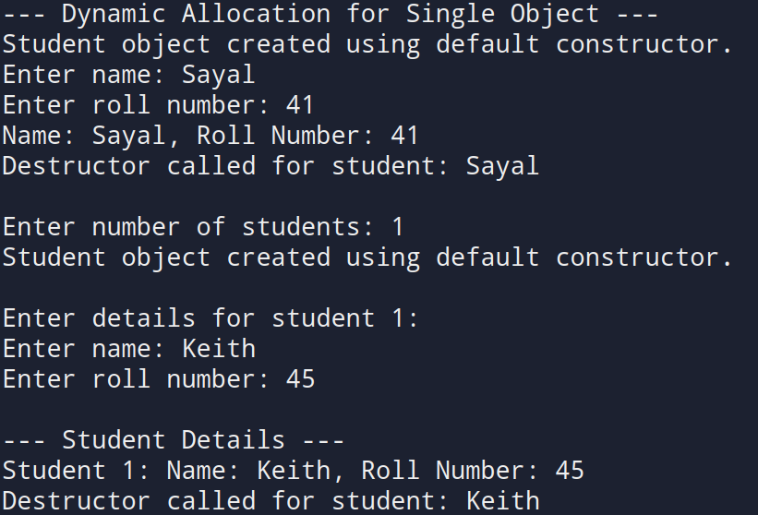
4. Write a program that demonstrates default, parameterized, and copy constructors. Use the this pointer to calculate mid point between two points.
#include <iostream>
using namespace std;
class Point {
private:
float x, y;
public:
// Default constructor
Point() {
x = 0;
y = 0;
cout << "Default constructor called.\n";
}
// Parameterized constructor
Point(float a, float b) {
x = a;
y = b;
cout << "Parameterized constructor called for (" << x << ", " << y << ")\n";
}
// Copy constructor
Point(const Point &p) {
x = p.x;
y = p.y;
cout << "Copy constructor called for (" << x << ", " << y << ")\n";
}
// Function to calculate midpoint using this pointer
Point midpoint(const Point &p) const {
float midX = (this->x + p.x) / 2;
float midY = (this->y + p.y) / 2;
return Point(midX, midY); // returning new object
}
void input() {
cout << "Enter x and y coordinates: ";
cin >> x >> y;
}
void display() const {
cout << "(" << x << ", " << y << ")" << endl;
}
};
int main() {
cout << "--- Enter Coordinates for Point 1 ---" << endl;
Point p1;
p1.input();
cout << "--- Enter Coordinates for Point 2 ---" << endl;
Point p2;
p2.input();
cout << "--- Copying Point 1 to Point 3 ---" << endl;
Point p3 = p1; // invokes copy constructor
cout << "\n--- Midpoint of Point 1 and Point 2 ---" << endl;
Point mid = p1.midpoint(p2); // uses this pointer
cout << "\nPoint 1: "; p1.display();
cout << "Point 2: "; p2.display();
cout << "Copied Point (p3): "; p3.display();
cout << "Midpoint: "; mid.display();
return 0;
}

OUTPUT
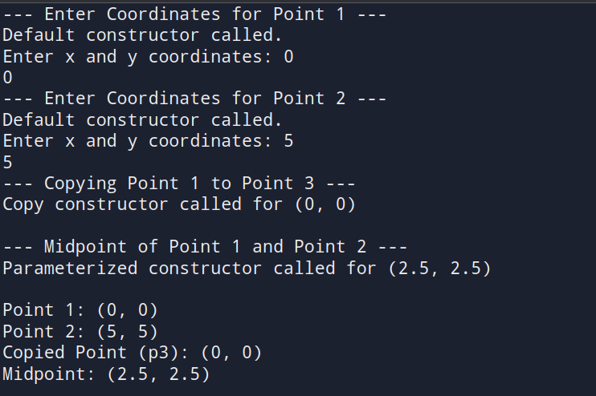
5. Write a program to define a function that takes an object as a reference parameter and modifies its data members
#include <iostream>
using namespace std;
class Student {
private:
string name;
int roll;
public:
// Default constructor
Student() {
name = "";
roll = 0;
}
// Function to input initial data
void input() {
cout << "Enter name: ";
getline(cin, name);
cout << "Enter roll number: ";
cin >> roll;
cin.ignore(); // Clear input buffer
}
// Function to display data
void display() const {
cout << "Name: " << name << ", Roll: " << roll << endl;
}
// Grant friend function access to modify data
friend void modify(Student &s);
};
// Function to modify object passed by reference
void modify(Student &s) {
cout << "\n--- Modifying Student Details ---" << endl;
cout << "Enter new name: ";
getline(cin, s.name);
cout << "Enter new roll number: ";
cin >> s.roll;
}
int main() {
Student s;
cout << "--- Enter Initial Student Data ---" << endl;
s.input();
cout << "\n--- Before Modification ---" << endl;
s.display();
modify(s);
cout << "\n--- After Modification ---" << endl;
s.display();
return 0;
}

OUTPUT
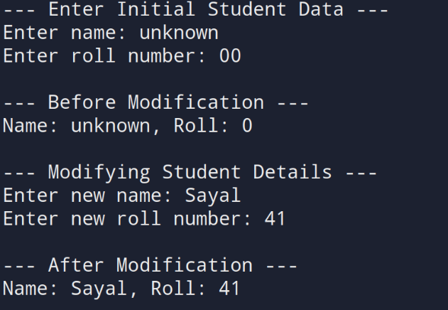
6. Write a program that defines a class inside a namespace and uses a reference to modify object attributes
#include <iostream>
#include <string>
using namespace std;

namespace School {
class Student {
private:
string name;
int roll;
public:
Student() {
name = "";
roll = 0;
}
void input() {
cout << "Enter student name: ";
getline(cin, name);
cout << "Enter roll number: ";
cin >> roll;
cin.ignore();
}
void display() const {
cout << "Name: " << name << ", Roll: " << roll << endl;}
friend void updateStudent(Student &s);
};
void updateStudent(Student &s) {
cout << "\n--- Modifying Student Data ---\n";
cout << "Enter new name: ";
getline(cin, s.name);
cout << "Enter new roll number: ";
cin >> s.roll;
cin.ignore();
}
}

int main() {
School::Student s;
cout << "--- Enter Student Data ---" << endl;
s.input();
cout << "\n--- Before Modification ---" << endl;
s.display();
School::updateStudent(s);
cout << "\n--- After Modification ---" << endl;
s.display();
return 0;
}

OUTPUT
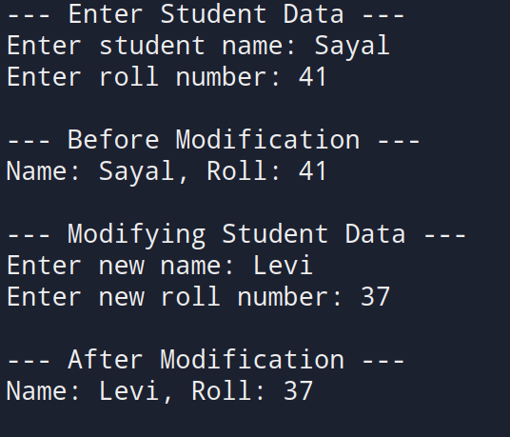
7. Write a program that defines a constant member function to access constant object data, and use const_cast to modify it safely.
#include <iostream>
using namespace std;
class Student {
private:
string name;
int roll;
public:
Student(string n = "N/A", int r = 0) {
name = n;
roll = r;
}
void display() const {
cout << "Name: " << name << ", Roll: " << roll << endl;
}
// Function to modify data using const_cast
void modify() const {
cout << "\n--- Attempting to Modify Constant Object ---" << endl;
// Cast away const-ness to modify data
Student* modifiable = const_cast<Student*>(this);
cout << "Enter new name: ";
getline(cin, modifiable->name);
cout << "Enter new roll number: ";
cin >> modifiable->roll;
cin.ignore(); // clear buffer
}
};
int main() {
// Creating a constant object
const Student s("Original", 101);
cout << "--- Constant Object (Before Modification) ---" << endl;
s.display();
// Modifying constant object using const_cast
s.modify();
cout << "\n--- Constant Object (After Modification) ---" << endl;
s.display();
return 0;
}

OUTPUT
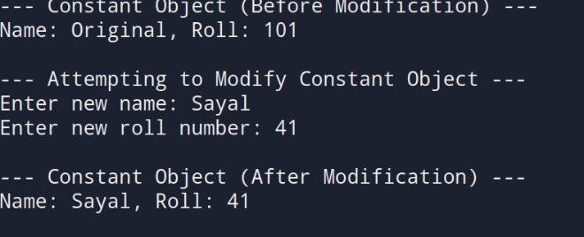
8. Write a program to demonstrate a friend function that accesses private data from two different classes and adds their values.
#include <iostream>
using namespace std;
class ClassB;
class ClassA {
private:
int valueA;
public:
ClassA(int a = 0) {
valueA = a;
}
friend int addValues(ClassA, ClassB);
};
class ClassB {
private:
int valueB;
public:
ClassB(int b = 0) {
valueB = b;
}
friend int addValues(ClassA, ClassB);
};
int addValues(ClassA a, ClassB b) {
return a.valueA + b.valueB;
}
int main() {
int x, y;
cout << "Enter value for ClassA: ";
cin >> x;
cout << "Enter value for ClassB: ";
cin >> y;
ClassA objA(x);
ClassB objB(y);
int result = addValues(objA, objB);
cout << "\nSum of values (ClassA + ClassB): " << result << endl;
return 0;
}
OUTPUT
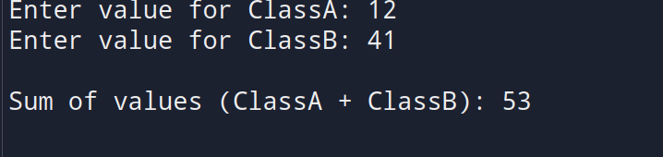
9. Write a program to define a class String that uses a dynamic constructor to allocate memory and join two strings entered by the user.
#include <iostream>
#include <cstring> // For strlen and strcpy
using namespace std;
class MyString {
private:
char* str;
public:
MyString(const char* s1, const char* s2) {
int len = strlen(s1) + strlen(s2);
str = new char[len + 1]; // +1 for null terminator
strcpy(str, s1);
strcat(str, s2);
cout << "Dynamic constructor called. Strings joined." << endl;
}
void display() const {
cout << "Joined String: " << str << endl;
}
~MyString() {
delete[] str;
cout << "Destructor called. Memory released." << endl;
}
};
int main() {
char input1[100], input2[100];
cout << "Enter first string: ";
cin.getline(input1, 100);
cout << "Enter second string: ";
cin.getline(input2, 100);
MyString s(input1, input2);
s.display();
return 0;
}
OUTPUT
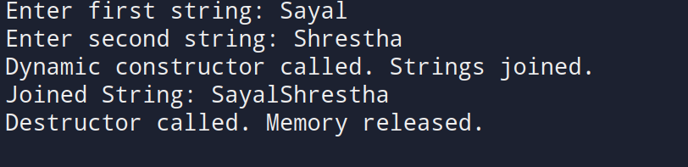
10. Write a program to define a class Rectangle with length and width. Implement a member function that takes another Rectangle object and returns a new object with combined dimensions.
#include <iostream>
using namespace std;
class Rectangle {
private:
float length, width;
public:
Rectangle() {
length = 0;
width = 0;
}
Rectangle(float l, float w) {
length = l;
width = w;
}
void input() {
cout << "Enter length: ";
cin >> length;
cout << "Enter width: ";
cin >> width;
}
void display() const {
cout << "Length: " << length << ", Width: " << width << endl;
}
Rectangle combine(const Rectangle &r) const {
float newLength = length + r.length;
float newWidth = width + r.width;
return Rectangle(newLength, newWidth);
}
};
int main() {
Rectangle r1, r2, r3;
cout << "--- Enter Dimensions for Rectangle 1 ---" << endl;
r1.input();
cout << "\n--- Enter Dimensions for Rectangle 2 ---" << endl;
r2.input();
// Combine dimensions using object as argument and return
r3 = r1.combine(r2);
cout << "\n--- Combined Rectangle ---" << endl;
r3.display();
return 0;
}
OUTPUT
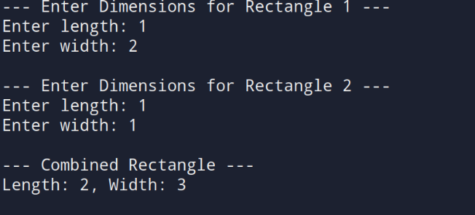

11. Write a program to create an array of five Employee objects, each with name and salary. Display the employee with the highest salary.
#include <iostream>
using namespace std;
class Employee {
private:
string name;
float salary;
public:
void input() {
cout << "Enter employee name: ";
cin.ignore(); // clear newline character
getline(cin, name);
cout << "Enter salary: ";
cin >> salary;
}
void display() const {
cout << "Name: " << name << ", Salary: Rs. " << salary << endl;
}
float getSalary() const {
return salary;
}};
int main() {
Employee emp[5];
int highestIndex = 0;
for (int i = 0; i < 5; i++) {
cout << "\n--- Enter Details for Employee " << i + 1 << " ---" << endl;
emp[i].input();
if (emp[i].getSalary() > emp[highestIndex].getSalary()) {
highestIndex = i;
}}
cout << "\n--- Employee with Highest Salary ---" << endl;
emp[highestIndex].display();
return 0;
}

OUTPUT
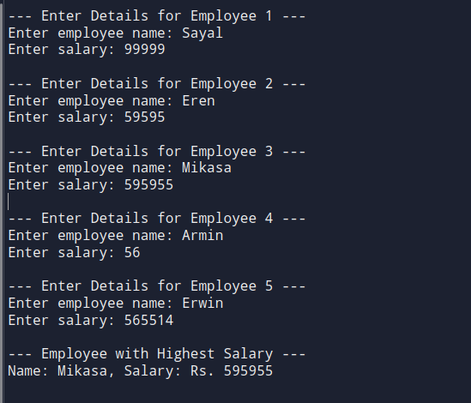
12. Write a program to define a class Point. Use pointers to dynamically allocate memory for two points and calculate the distance between them.
#include <iostream>
#include <cmath> // For sqrt and pow
using namespace std;
class Point {
private:
float x, y;
public:
// Constructor
Point(float a = 0, float b = 0) {
x = a;
y = b;
}
void input() {
cout << "Enter x and y coordinates: ";
cin >> x >> y;
}
friend float distance(Point* p1, Point* p2);
};
float distance(Point* p1, Point* p2) {
return sqrt(pow(p2->x - p1->x, 2) + pow(p2->y - p1->y, 2));
}
int main() {
Point* point1 = new Point();
Point* point2 = new Point();
cout << "--- Enter coordinates for Point 1 ---" << endl;
point1->input();
cout << "\n--- Enter coordinates for Point 2 ---" << endl;
point2->input();
float d = distance(point1, point2);
cout << "\nDistance between the two points: " << d << endl;
// Deallocate memory
delete point1;
delete point2;
return 0;
}

OUTPUT
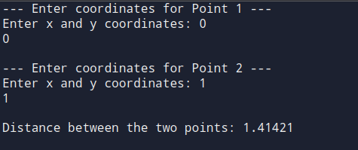
13. Write a program to define a class Box. Use the this pointer in a member function to compare two boxes and return the one with the greater volume.
#include <iostream>
using namespace std;
class Box {
private:
float length, width, height;
public:
Box(float l = 1, float w = 1, float h = 1) {
length = l;
width = w;
height = h;
}
void input() {
cout << "Enter length, width, and height: ";
cin >> length >> width >> height;
}
float volume() const {
return length * width * height;
}
Box compare(const Box& b) const {
if (this->volume() > b.volume()) {
return *this; // current object has greater volume
} else {
return b; // parameter object has greater volume
}
}
void display() const {
cout << "Dimensions (LxWxH): " << length << " x " << width << " x " << height << endl;
cout << "Volume: " << volume() << endl;
}
};
int main() {
Box box1, box2;
cout << "--- Enter details for Box 1 ---" << endl;
box1.input();
cout << "\n--- Enter details for Box 2 ---" << endl;
box2.input();
Box bigger = box1.compare(box2); // compare using 'this' pointer
cout << "\n--- Box with Greater Volume ---" << endl;
bigger.display();
return 0;
}
OUTPUT
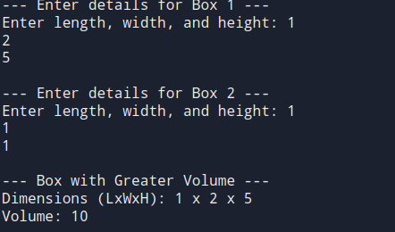

DISCUSSION
This lab demonstrated key object-oriented programming concepts in C++ through 13 programs. We practiced creating classes, using different constructors, managing memory with new/delete, and applying friend functions, namespaces, and the this pointer. Real-world examples helped reinforce abstract concepts like object copying, reference modification, and memory-safe design.

CONCLUSION
Through this lab, we strengthened our understanding of classes, constructors, destructors, and object management in C++. We also learned practical techniques for memory handling, code modularity, and safe data access—forming a solid base for further C++ programming.

